Anna Preston has a unique dance background in concert, commercial, and educational dance. She was a performer, and the rehearsal director, of a Guggenheim recipient directed and Bessie nominated contemporary dance company, Demetrius Klein Dance Company (DKDC). DKDC toured throughout the United States. The company went to France as a cultural ambassador for Florida arts and culture. She performed in collaborative dance concerts with Mia Michaels and Mikhail Baryshnikov. As the rehearsal director, she gave master classes in the communities where they performed.

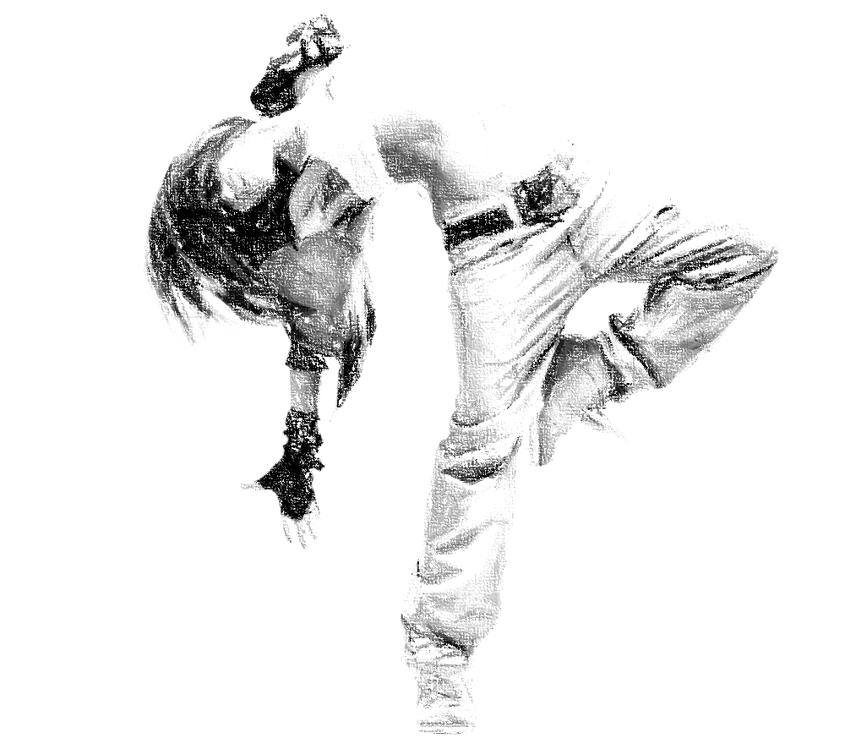

Anna spent four years as a performer and staging specialist for Walt Disney World in Orlando. She performed several dance roles and was responsible for instructing choreography and critiquing stage shows and parades.

Ms. Preston taught dance at Palm Beach State College and dance and theatre at Palm Beach Atlantic University (PBAU) for over a decade. At PBAU she was on the team that created the Dance Minor program. Her classes included technique in multiple genres, choreography and composition, dance production, dance and musical theatre history, and stage movement.

This background gives Ms. Preston a comprehensive perspective as she leads young artists, recognizing the different paths they may choose to follow in dance.